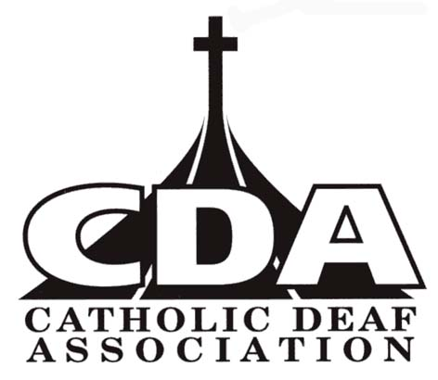

Dear members,

It is with great regret that we need to inform you the December issue (December 2018) will be the last printed Outreach magazine you will receive.

As a result of the resolution which was unanimously accepted by members at the AGM held in Preston on 27th October 2018, due to the high cost of print and posting we will no longer send free glossy Outreach magazine.

Please note, some people do not realise that the £10 annual membership is not for Outreach. It is to support the work of the CDA that we try to do in the United Kingdom and members receive a free copy of Outreach magazine.

In future, we will still send you Outreach newsletters. To cut the cost of sending Outreach, we are going to post news on our CDA website and of course we can email you the newsletters and you can read them on your computer, electronic device or your mobile.

We know some of you do not have computers and if you prefer to have printed newsletters, we can still post it to you. The newsletters will be in colour but printed on a photocopier and folded in half and posted in an A5 envelope. Unfortunately, you will have to pay for the cost of printed newsletters and postage. The price for the newsletters will be £3.00 and it will be posted to you twice a year in June/July and December. However, newsletters sent by email and posted on our website will be free.

If you wish to receive Outreach newsletter by email, click ‘Sign up directly’ on the website.

If you wish to receive the newsletter please fill in below and send to the Secretary. Please be aware this is on top of the £10 annual membership that we rely so much for the missionary work with Deaf people.

 ----------------------------------------------------------------------------------------------------------------------------------------------

I wish to receive Outreach newsletters by post in June/July and December:

Name............................................................................................................................

Address...........................................................................................................................................................................

.....................................................................................................................................................................................

I enclose £3.00 for printed Outreach newsletters for the year 2019.

Send to
Fr Robin Ellwood (Secretary), Chestnut Cottage, 18 Englefield Road, Theale, Reading RG7 5AS.
Cheque payable to ‘Catholic Deaf Association’.

