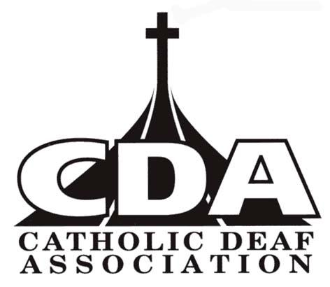
CATHOLIC DEAF ASSOCIATION
Hollywood House, 2 Nobby Stiles Drive, Collyhurst, Manchester M4 4FA
Email: catholicdeaf1971@gmail.com

Standing Order (for annual CDA membership)
Your name _______________________________________
Your address __________________________________________________________________________
___________________________________________________ Post Code _________________________

Your bank name and address: ………………………………………………………………..…………………..………………………………
………………………………………………………………………………………………………………………………………………………..…………
Name of account holder: ……………………………………………………………………………………..……………

£1 on the first day of each month £ ____.____ donation per year (optional)

To the bank: please deduct a total of £1.00
from my account the following calendar month until further notice

Account number: ……………………………………….. Bank Sort Code: __ __ - __ __ - __ __

Payable to: Catholic Deaf Association
Royal Bank of Scotland, St Anne Square, Manchester M60 2SS
Account Sort Code: 16-00-18
Account no: 41479811

Please ensure that the reference ‘Catholic Deaf Association - …..(Donor surname)…..’ - is quoted on the recipient’s bank statement.

Signature: ……………………………………………………..…………….. Date ………………………………..

Please return this form to
CDA Treasurer, Chestnut Cottage, 18 Englefield Road, Theale, Reading RG7 5AS NOT to your bank.
Thank you.

