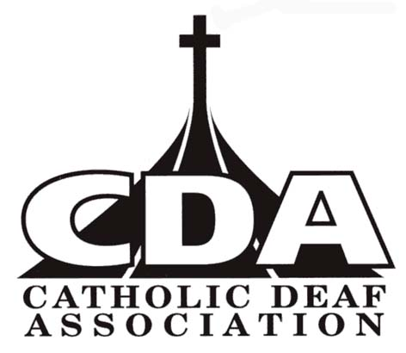
CATHOLIC DEAF ASSOCIATION
Hollywood House, 2 Nobby Stiles Drive, Collyhurst, Manchester M4 4FA
Email: catholicdeaf1971@gmail.com

Annual CDA membership
Your name _________________________________________________________________________
Your address _________________________________________________________________________
___________________________________________________ Post Code ________________________
Email _________________________________________________________________________________

Individual membership (cheque or DD) | £10 for 12 months
Individual membership (Standing Order) | £1.00 on the 1st day of the month (£12 per year)
Family/Couple membership | £15 for 12 months
Life Membership - Individual | £70.00
Life Membership - Family/Couple | £90.00
Life Membership - Over 60s | £60.00

I wish to pay CDA membership by:  Cheque   Standing Order   Direct Debit

Membership | £
Outreach newsletter (£3.00) | £
I wish to donate towards the work of the Catholic Deaf Association | £
Total | £

Please make cheque payable to CATHOLIC DEAF ASSOCIATION

Please note CDA membership is to support the work of the CDA. Unfortunately we no longer send out
free Outreach magazine (2018 AGM’s decision). We will continue to send Outreach newsletters by email (free). But if you wish to receive a printed copy of Outreach newsletter, it will cost £3.00 per year.

Signature: ……………………………………………………..…………….. Date ………………………………..

Please return this form to
CDA Treasurer, Chestnut Cottage, 18 Englefield Road, Theale, Reading RG7 5AS. If you wish to pay by DD or SO, don’t forget to fill in the DD form or SO form and send it to the Secretary, NOT to your bank. Thank you.

Registered Charity No 262362

